# Statistic Test: Analysis of Variance (ANOVA)

Overall Objective of this Study:

Is there a significant difference for hours played on average each month between the players of different levels?

The independent variable will be the level of players grouped by bracket. The dependent variable will be HRS1 which contains the number of hours played by month for players who answered the survey.

**Descriptive Statistics**

First, let’s look at the averages, standard deviation and confidence intervals for each group.

|  |  |  |  |  |  |  |  |  |  |  |  |
| --- | --- | --- | --- | --- | --- | --- | --- | --- | --- | --- | --- |
|  |  |  |  |  |  | **Descriptives (stats)** *hrs1* | | |  |  |  |
|  |  |  |  |  |  |  |  | |  |  |  |
|  |  |  |  |  |  |  | 95% confidence interval for Mean | | |  |  |
| Group # | Level bounds | | N | Mean | Std.Deviation | Std. Error | Lower Bound | Upper Bound | | Minimum | Maximum |
| *0* | 1 | 10 | 95 | 36.82 | 14.257 | 1.463 | 33.92 | 39.73 | | 5 | 87 |
| *1* | 11 | 20 | 463 | 42.20 | 13.041 | 0.606 | 41.01 | 43.39 | | 3 | 89 |
| *2* | 21 | 30 | 75 | 41.97 | 13.776 | 1.591 | 38.80 | 45.14 | | 4 | 80 |
| *3* | 31 | 40 | 191 | 44.28 | 14.075 | 1.018 | 42.27 | 46.29 | | 5 | 89 |
| *4* | 41 | 50 | 80 | 47.29 | 14.185 | 1.586 | 44.13 | 50.44 | | 6 | 80 |
|  | Total | | 904 | 42.50 | 13.754 | 0.457 | 41.61 | 43.40 | | 3 | 89 |

1. **Please interpret this table.**

|  |
| --- |
| **The table has 5 population groups each with its own mean and std deviation. Mean of group0 appears to be less than average mean of the groups and mean of group5 also appears to be higher. Group0 also has less std deviation than the other** |

To analyze the distribution of HRS1 values per group, we look at the graph of error bars:

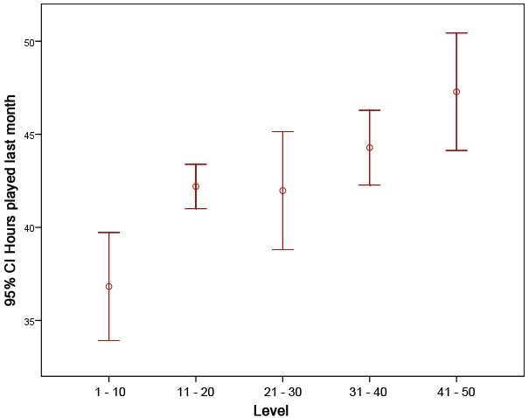

1. **Please interpret this graph**

|  |
| --- |
| **The variance of the 11-20, 31-40 groups appears to be less than the other groups. Also the means of 1-10 group and 41-50 group appear to be differing more significantly from the groups of the other three groups and have a higher variance. Variance of the 21-30 group also appear to be high.** |

**Variances homogeneity**

Before looking at the results of the ANOVA, it is important to check the assumption of equality of variances with the test of Levene:

|  |  |  |  |
| --- | --- | --- | --- |
|  | **Levene's Test for equality of Variances** | |  |
| Levene Statistic | df1 | df2 | Sig. |
| 1.179 | 4 | 899 | 0.319 |

1. **Please interpret this table**

|  |
| --- |
| **This test states that the null hypothesis indicating homogeneity of variances cannot be rejected with high confidence.** |

**Results of the ANOVA**

Let’s look now at the results of the ANOVA:

|  |  |  |  |  |  |
| --- | --- | --- | --- | --- | --- |
|  |  | **Anova** |  |  |  |
|  |  |  |  |  |  |
|  | Sum of Squares | df | Mean Square | F | Sig. |
| Between groups | 5,567.843 | 4 | 1,391.961 | 7.572 | •000 |
| Within Groups | 165,264.140 | 889 | 183.831 |  |  |
| Total | 170,831.982 | 903 |  |  |  |

1. **Please interpret this table**

|  |
| --- |
| **This F-test/p-value indicates that we can reject the null hypothesis, the group means cannot be assumed to be from the same populations with high confidence and are likely to be unequal.** |

**Multiple Comparisons**

Following this analysis of variance, it’s needed to do a post-hoc test.

Explain why and interpret the following table:

|  |  |  |  |  |  |
| --- | --- | --- | --- | --- | --- |
| Level (I) / Level (J) | Mean Difference (l-J) | Std. Error | Sig. | 95% confidence interval for Mean | |
| Lower Bound | Upper Bound |
| 0 - Level 1 - 10/ 1 - Level 11 - 20 | **-5,37\*** | 1.527 | 0.005 | -9.67 | -1.08 |
| 2 - Level 21 - 30 | -5.152 | 2094, | 0.141 | -11.05 | 0,74 |
| 3 - Level 31 - 40 | -7,462* | 1.702 | .000 | -12.25 | -2.67 |
| 4 - Level 41 - 50 | -10,466* | 2057, | .000 | -16.26 | -4.68 |
| 1 - Level 11 - 20/ 0 - Level 1 - 10 | **5,37\*** | 1.527 | 0.005 | 1.08 | 9.67 |
| 2 - Level 21 - 30 | 0.223 | 1.688 | 1.000 | -4.53 | 4.97 |
| 3 - Level 31 - 40 | -2.086 | 1.166 | *0.739* | -5.37 | 1.19 |
| 4 - Level 41 - 50 | -5,091* | 1.642 | .020 | -9.71 | -0.47 |
| 2 - Level 21 - 30/ 0 - Level 1 - 10 | 5.152 | 2.094 | 0.141 | -0.74 | 11.05 |
| 1 - Level 11 - 20 | -0.223 | 1.688 | 1.000 | -4.97 | 4.53 |
| 3 - Level 31 - 40 | -2.309 | 1.848 | 1.000 | -7.51 | 2.89 |
| 4 - Level 41 - 50 | -5.314 | 2.179 | 0.149 | -11.45 | 0,82 |
| 3 - Level 31 - 40/ 0 - Level 1 - 10 | 7,462* | 1.702 | .000 | 2.67 | 12.25 |
| 1 - Level 11 - 20 | 2.086 | 1.166 | *0.739* | -1.19 | 5.37 |
| 2 - Level 21 - 30 | 2.309 | 1.848 | 1.000 | -2.89 | 7.51 |
| 4 - Level 41 - 50 | -3.005 | 1.806 | 0.964 | -8.09 | 2.08 |
| 4 - Level 41 - 50/ 0 - Level 1 - 10 | **10,466\*** | 2.057 | .000 | 4.68 | 16.26 |
| 1 - Level 11 - 20 | **5,091\*** | 1.642 | .020 | 0.47 | 9.71 |
| 2 - Level 21 - 30 | 5.314 | 2.179 | 0.149 | -0.82 | 11.45 |
| 3 - Level 31 - 40 | 3.005 | 1.806 | 0.964 | -2.08 | 8.09 |

**ANSWER**

|  |
| --- |
| **The F test only tells us if the null hypothesis stating equality of means can be rejected with confidence and we found that it could. However it does not tell us which sample means are unequal. The above post-hoc test gives us this information. It tells us that the mean from group0 cannot be assumed to be equal to the mean from group1,3 or 4 with high confidence. It also indicates inequality of means of groups 1 and 4,** |